**1.Creating S3 Bucket with No Public Access**

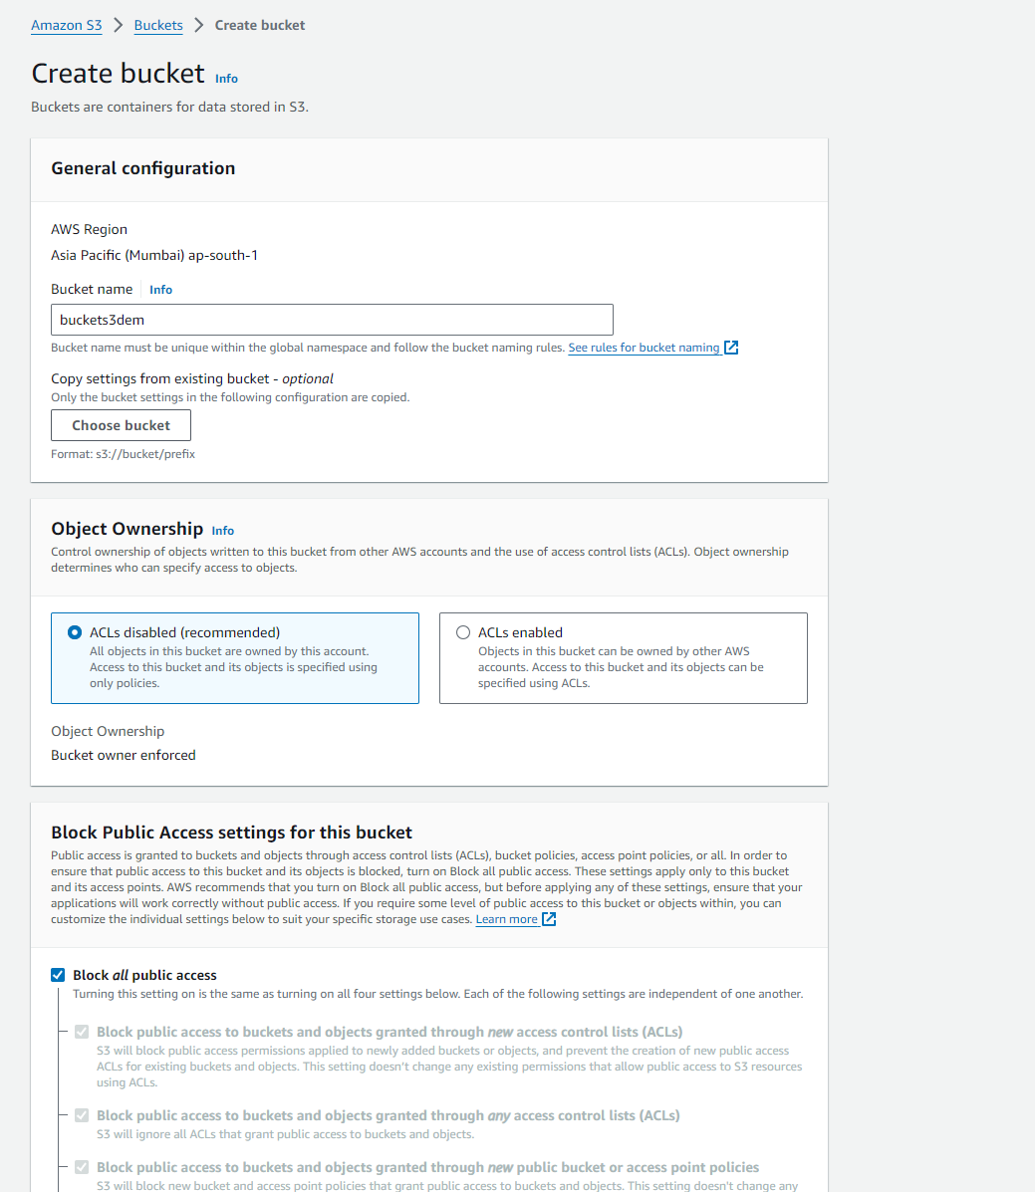

**2.S3 Bucket Created**

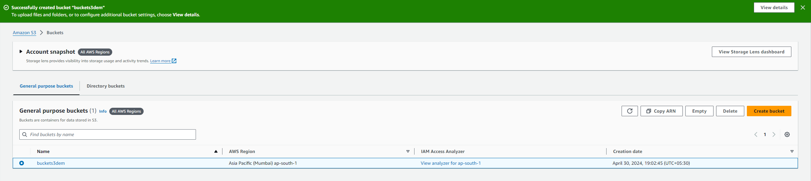

**3.Bucket file Uploading page**

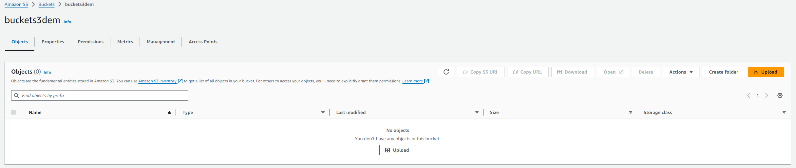

**4.Uploading Files in S3 Bucket**

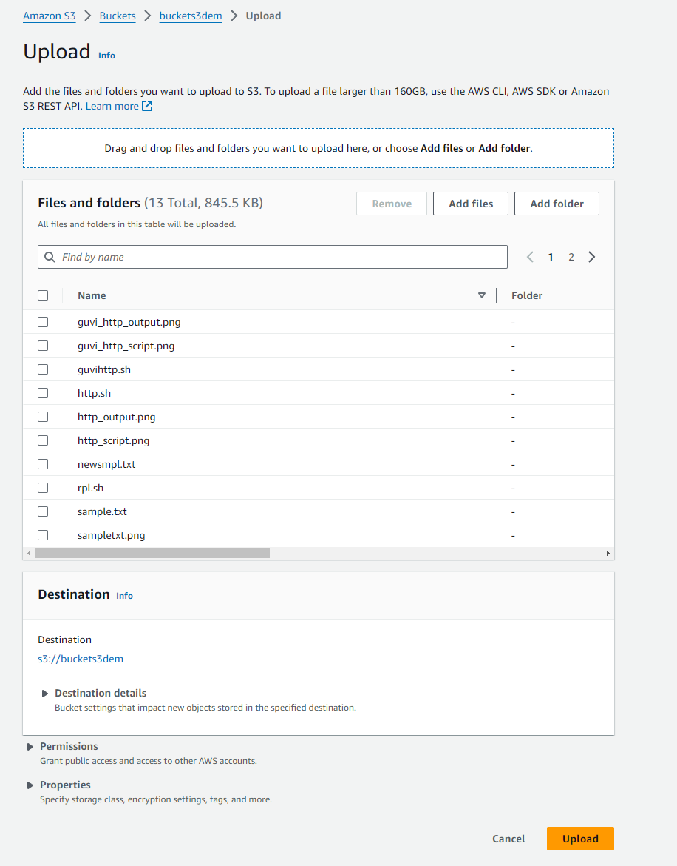

**5.Files Uploaded to S3 Bucket**

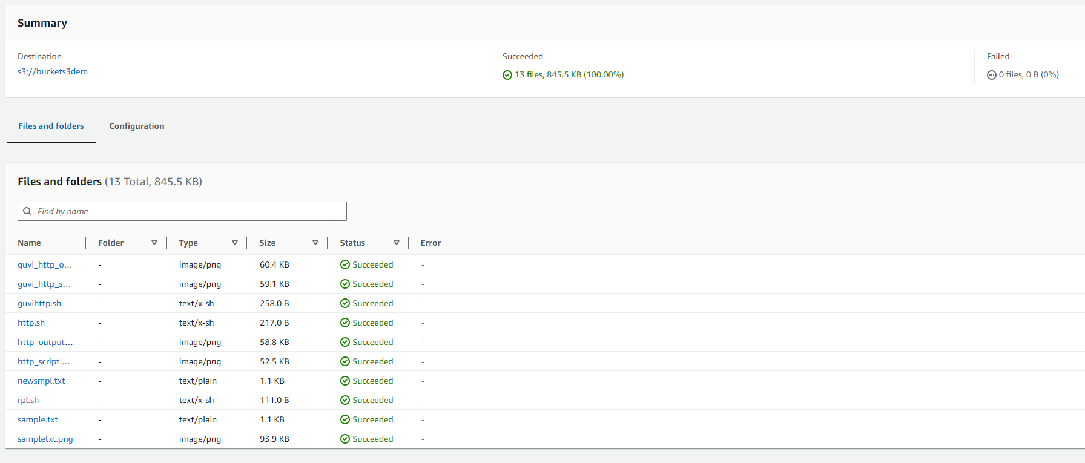

**6.No Public Access for the Bucket we created**

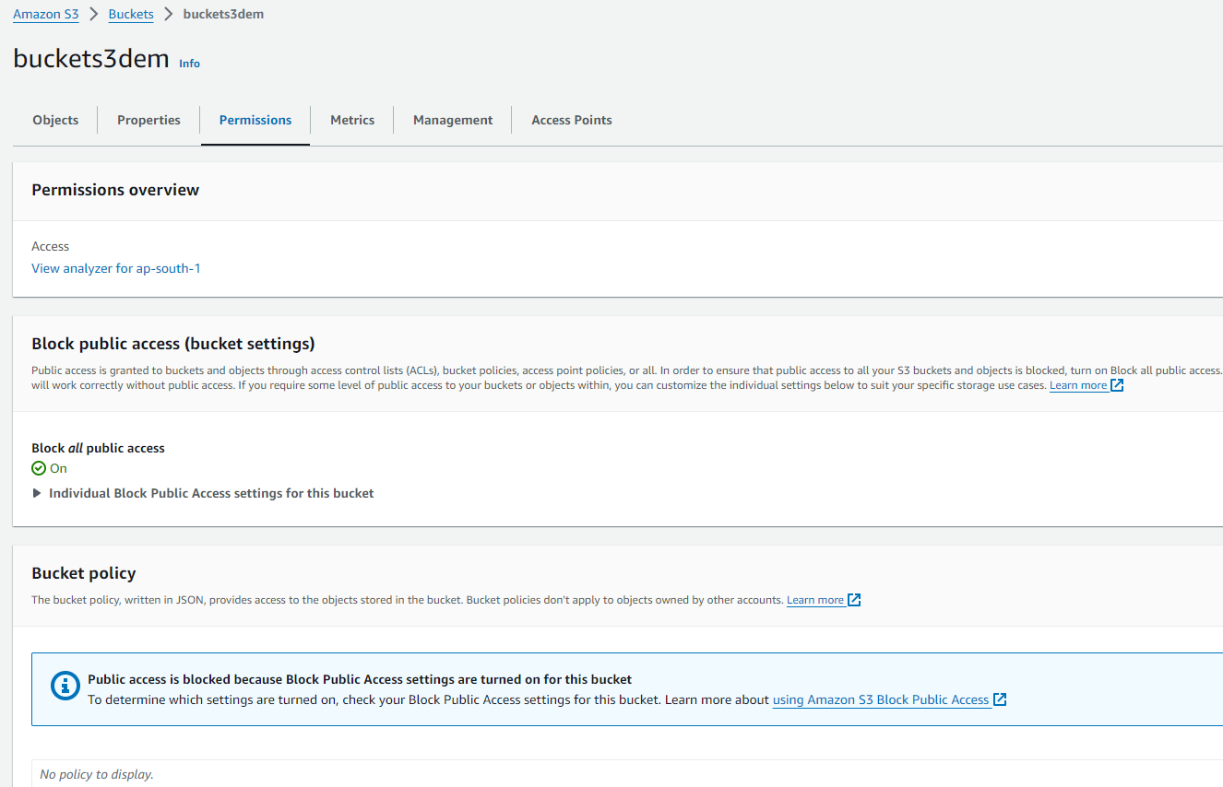

**7.Enabling Server Access Logging details**

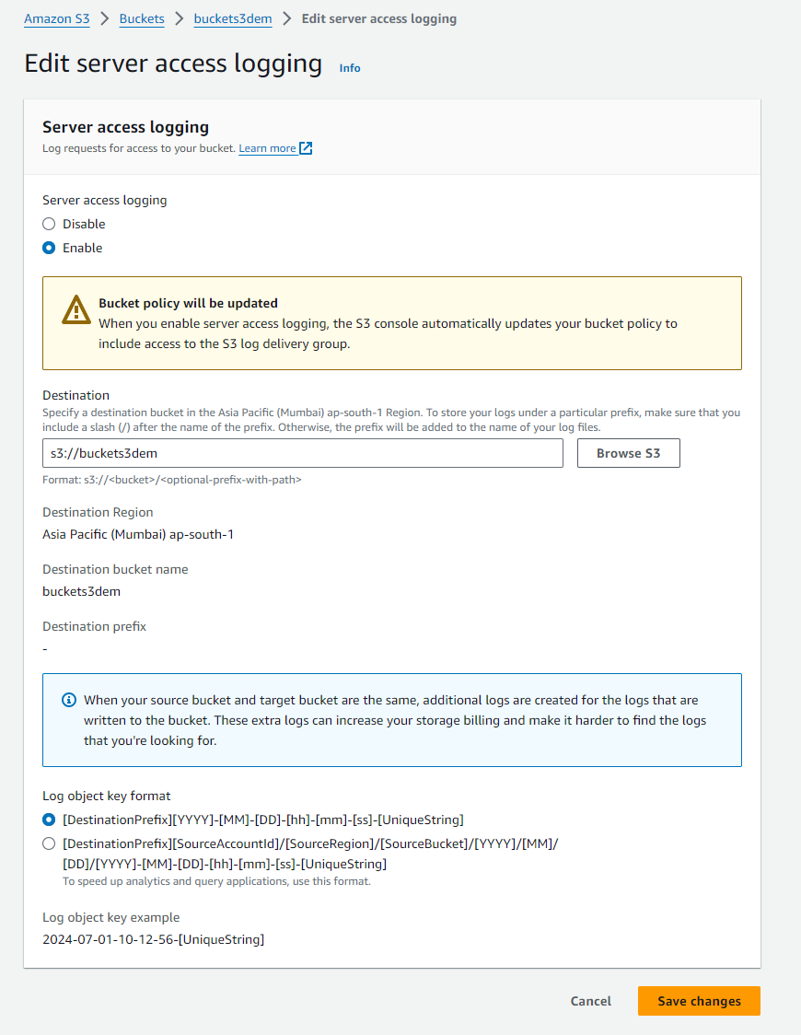

**8. Created New Folder and Moved the files to the folder**

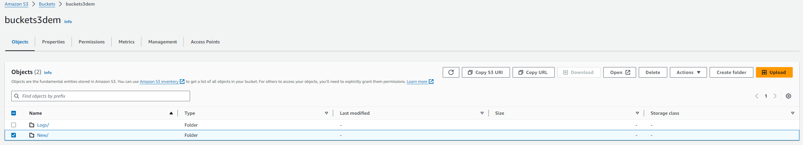

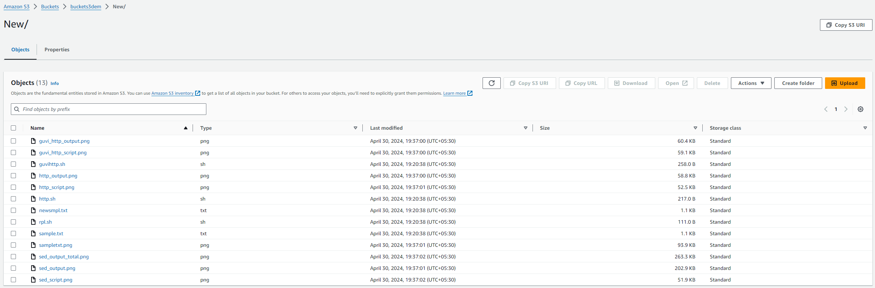

**9.Created Logs Folder for Logs Files to be stored in Logs folder**

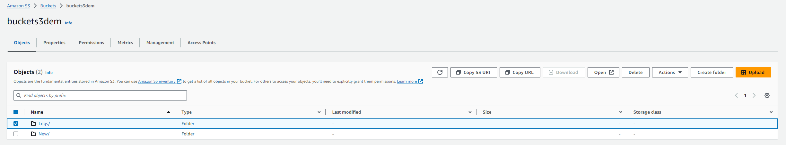

**10. Logs files stored separately in Logs Folder**

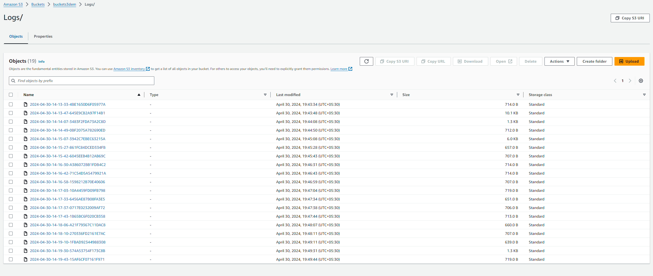

**11.Creating Instances using Auto Scaling Group**

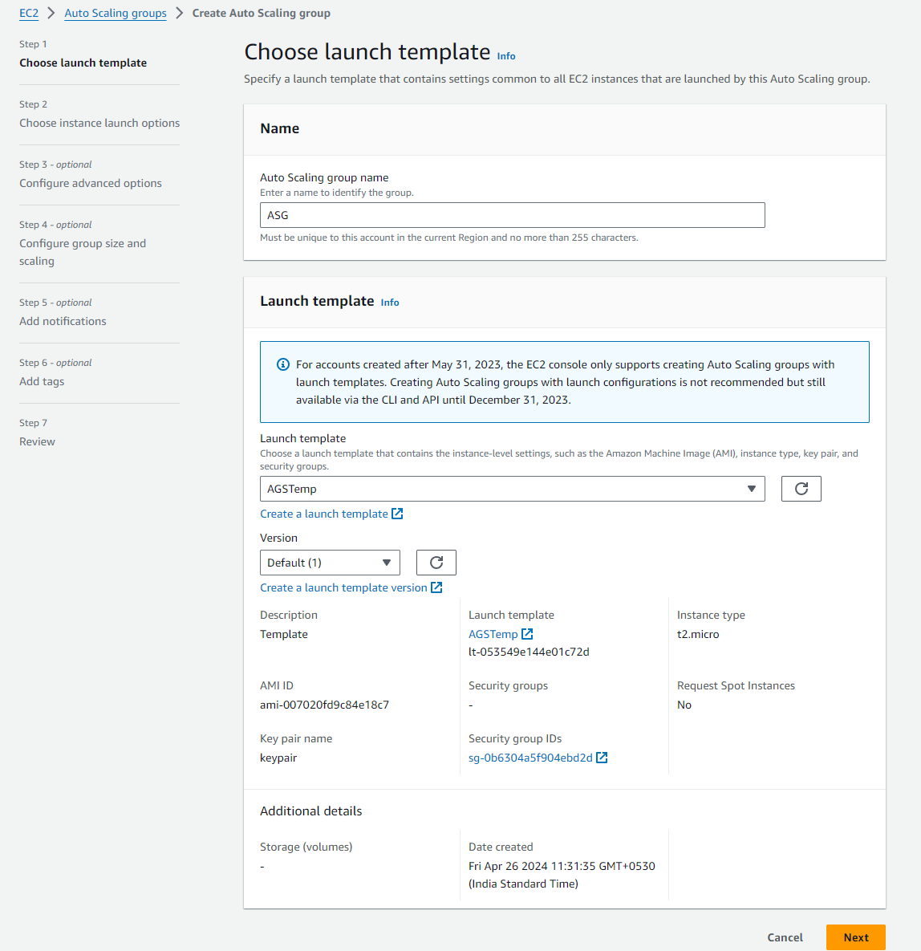

**12. Two instances Created with Applications. Both are running in Different IP**

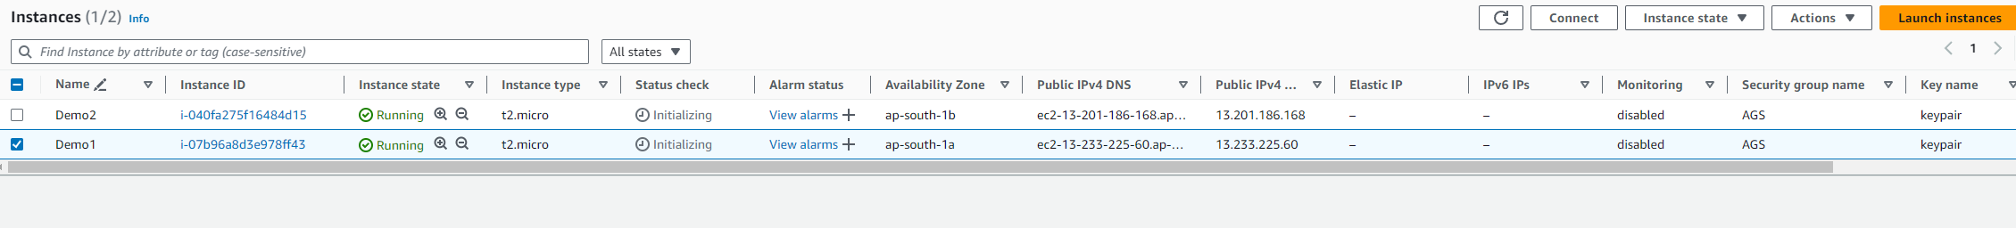





**13.Creating Applications Load Balancer**

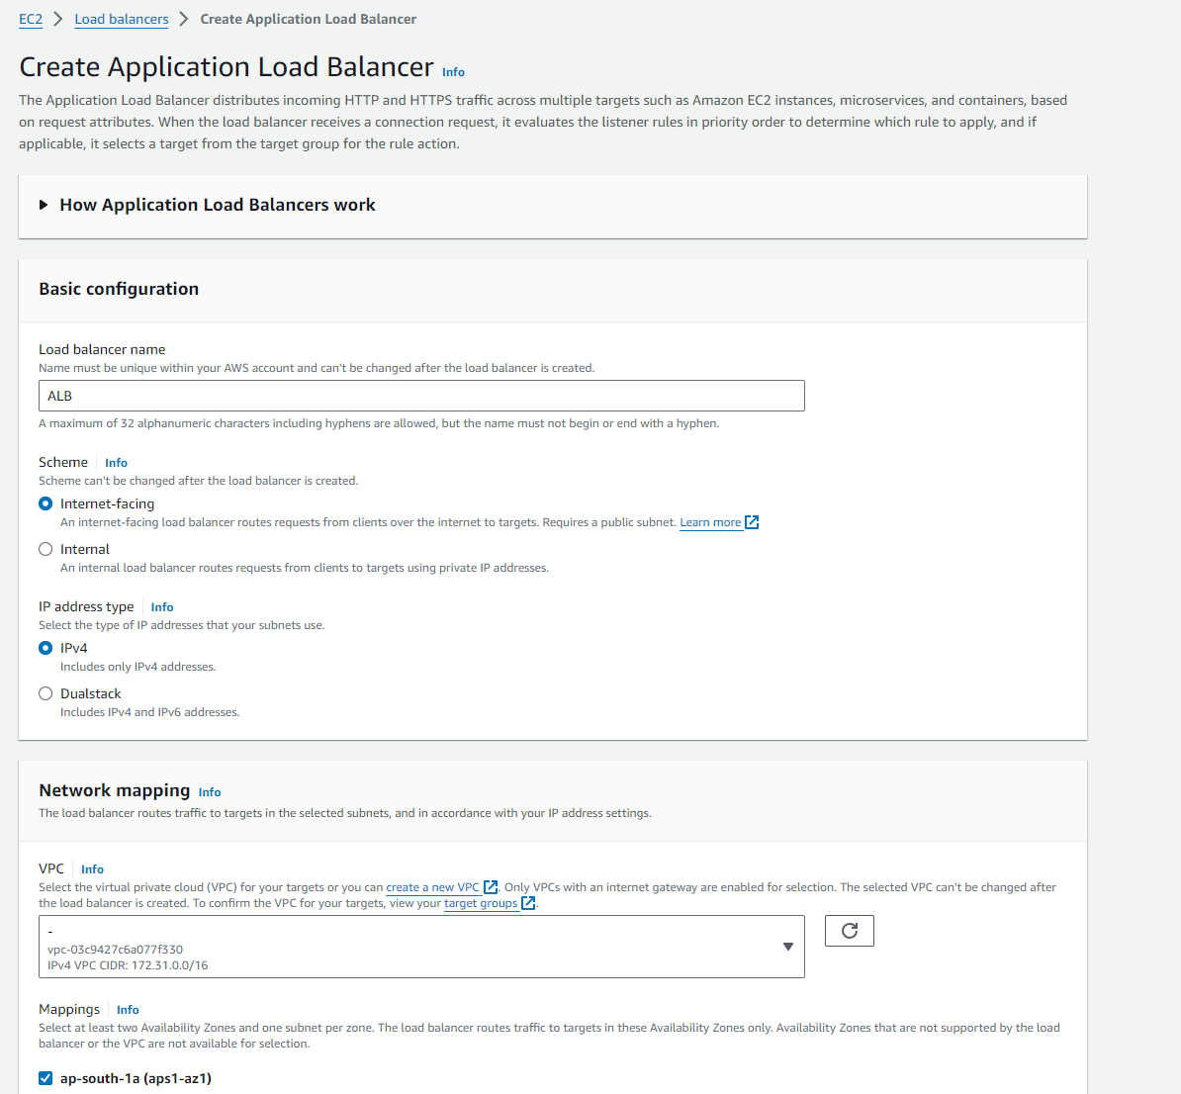

**14. Creating Target Group for App Load Balancer**

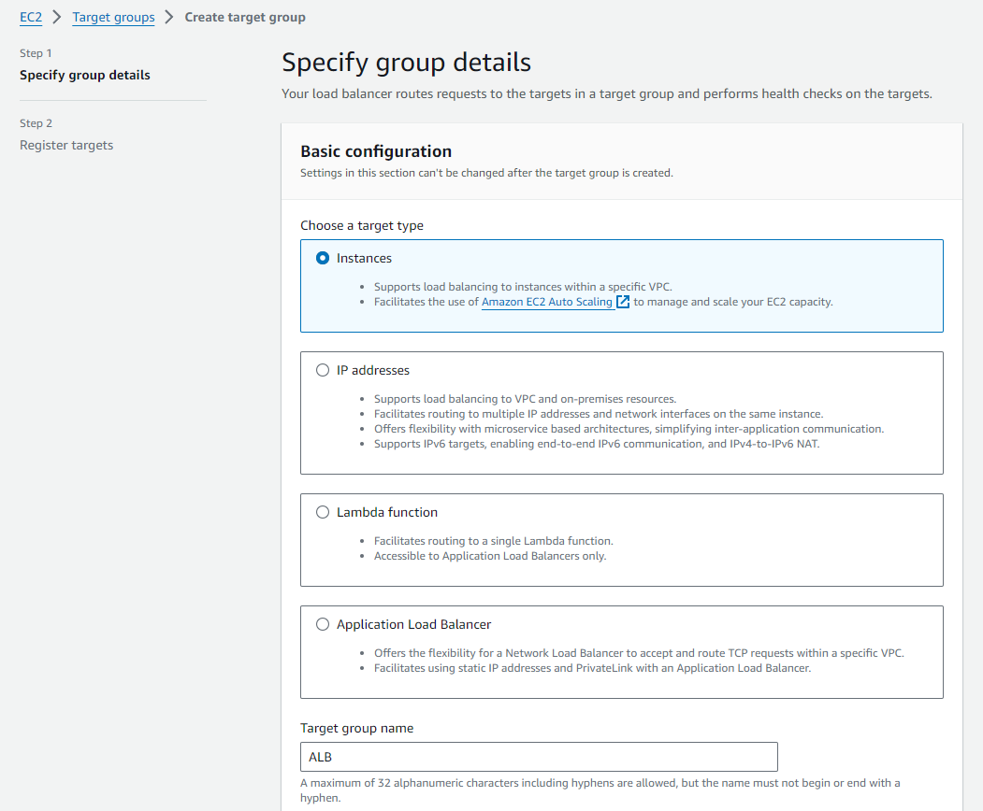

**15.Target Instances selected to connect with Load Balancer**

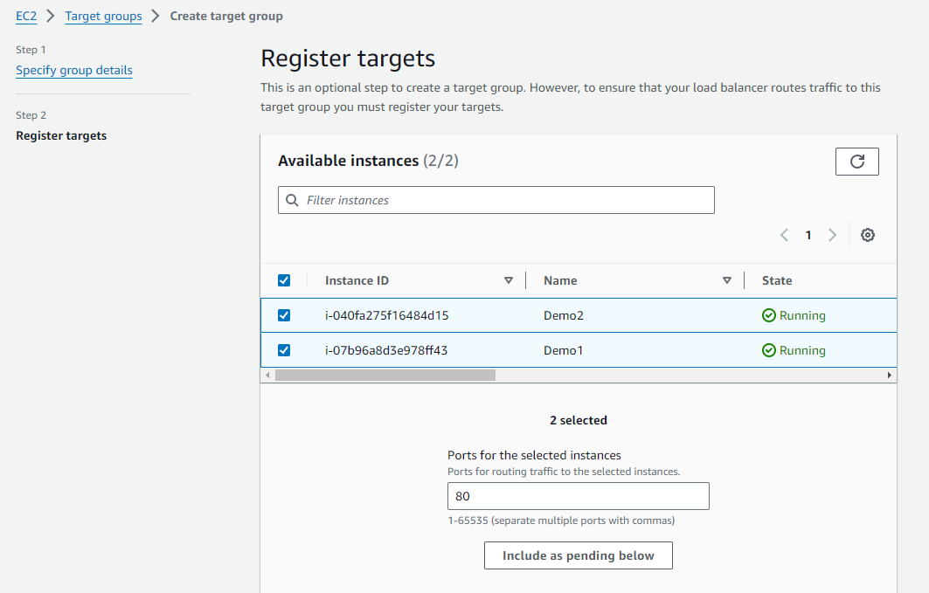

**16. Two Instances initialized and Running Healthy in Target Group**

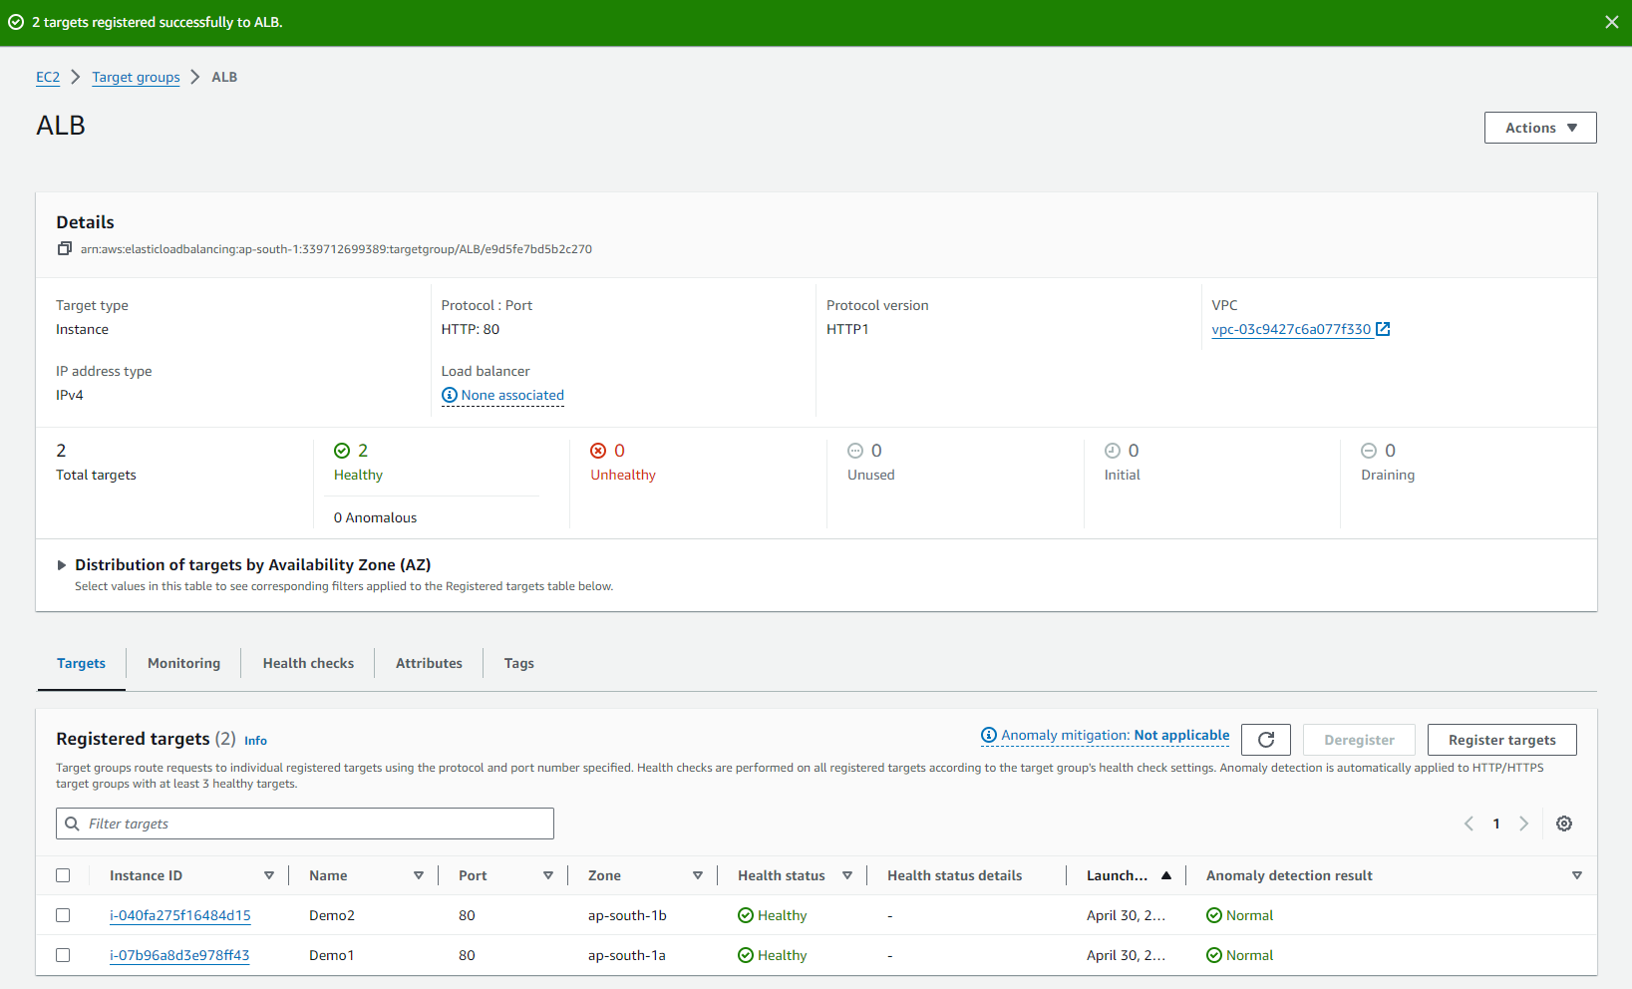

**17.Summary of App Load Balancer .Both Instances are connected with Load Balancer by Target Group**

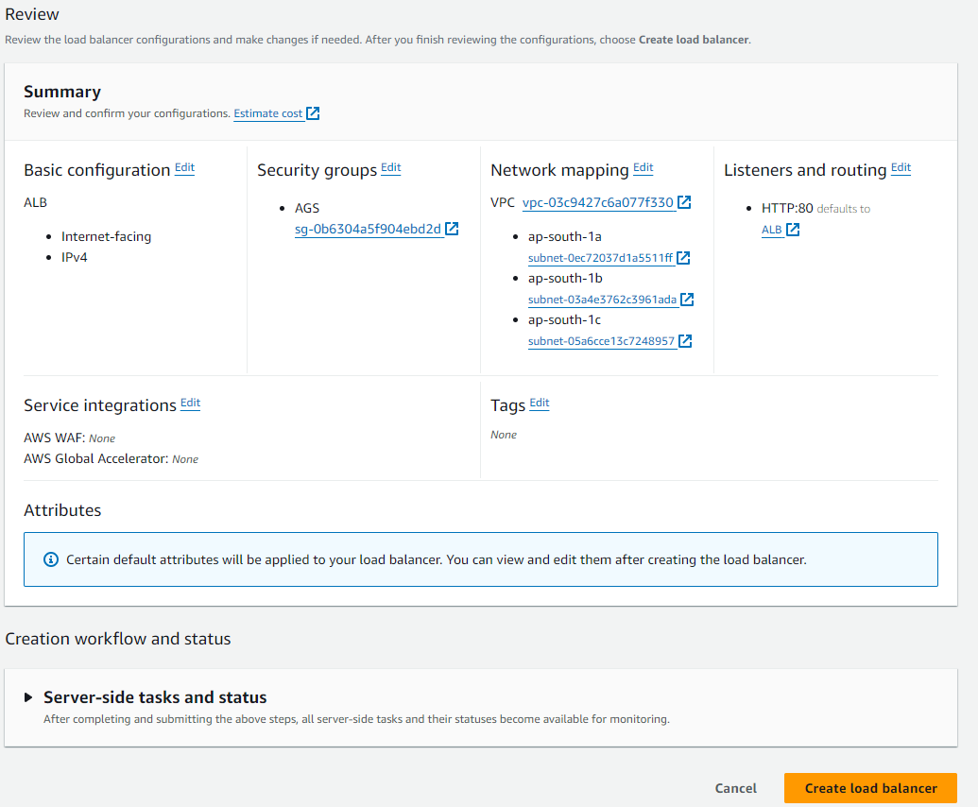

**18. App Load Balancer is Running**

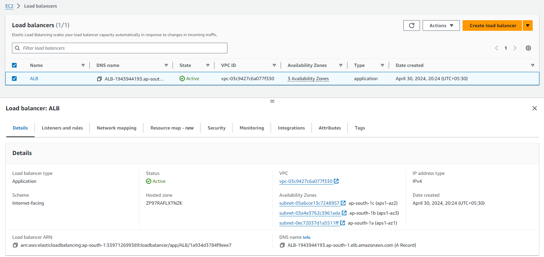

**19.Application Output traffics from the server to Load Balancer IP**

